

**Development of Robust Micro faCE Emotion Detection**

Graduation project proposal

submitted in partial fulfillment of the requirements for the

**Bachelor of the Science of Engineering Honors Degree**

In

The Department of Electrical and Telecommunication Engineering

Faculty of Engineering

South Eastern University of Sri Lanka

University Park, Oluvil, #32360

Sri Lanka

by

**K.T.J Prabhanuka (SEU/IS/15/EG/068)**

**D.M.I.S.Dissanayaka(SEU/IS/15/EG/072)**

Supervised by:

Dr. W.G.C.W kumara

Eng. R.Hirshan

Eng.M.N.M Aashiq

25 October 2020

# SUMMARY

We focus to detect micro emotions which are draws in human face instantly,which can be used for various fields such as Crime investigations; Medical Scanning ; Employee Welfare management…etc

Mainly we hope to detect suspicious expressions while inquiring from suspectives, in criminal cases by using a Slow Motion Camera,which has a high FPS(FRAMES PER SECOND) to detect the micro emotions drawn on a suspective face,and using tools of Opencv and Openpose and convert it into alert signal.

In addition to slow motion camera,we hope to improve it using a thermal Scanning camera, as the secondary capture device to improve the accuracy of the result

And this project final outcome will be detecting basic types of micro emotions and developing a detection system,and alerting system for the required objective.

# TABLE OF CONTENTS

[SUMMARY i](#_Toc53749645)

[TABLE OF CONTENTS ii](#_Toc53749646)

[1. INTRODUCTION 1](#_Toc53749647)

[1.1. BACKGROUND 1](#_Toc53749648)

[1.2. PROJECT AIM 2](#_Toc53749649)

[1.3. PROJECT OBJECTIVES 2](#_Toc53749650)

[2. LITERATURE REVIEW 3](#_Toc53749651)

[3. METHODOLOGY 4](#_Toc53749652)

[4. PROJECT PLAN AND TIMELINE 5](#_Toc53749653)

[5. REFERENCES 6](#_Toc53749654)

# INTRODUCTION

## BACKGROUND

* + 1. **Facial Expression**

Considering humans interact with each other, they mainly use physical ways like speaking, body gesturing, and displaying emotions. Humans use many ways to express their emotions. Among them, the most natural and effective way to display emotions is by using facial expressions. It is an important part of nonverbal communication. It is widely accepted from the psychological theory that human emotions can be classified into 8 states:as follows; disgust, surprise, sadness, anger, happiness, fear, contempt and neutral. Neutral always used as a reference. For our project purpose, we were considered only six emotions. Because there is a 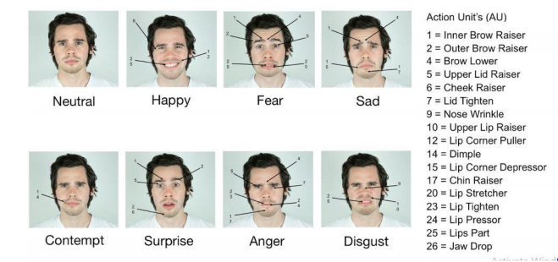similarity between sad and contempt, so we labeled those two classes as sad.

* + 1. **Micro Expressions**

Micro expressions are facial expressions that occur within a fraction of a second. This involuntary emotional leakage exposes a person's true emotions.

Micro-expressions often occur as fast as 1/15 to 1/25 of a second. And also these expressions are usually low in intensity, the full extension of the facial muscles with suppression may be too short. Because of the short duration and low intensity, it is usually

Micro-expression is a brief facial movement that appears on a person’s face according to the emotions being experienced. It cannot be controlled by a person, thus may provide useful clues to detecting lies. Therefore, micro-expression recognition has many potential applications such as criminal interrogations and identify the patient’s emotional levels.

Differences between Macro and Micro Emotions are classified as follows;

|  |  |
| --- | --- |
| **Macro Expressions** | **Micro Expressions** |
| Obvious Or “Normal” facial expressions | Often Misinterpreted or missed alltogether |
| Last between ½ a second to 4 seconds | Occurs in ½ a second or less |
| Carefully expressed;not presenting actual situation | Unconsciously display a concealed emotion |
| Can be displayed,according to theirself current mood | Occur in every where,often without their knowledge |
| Can be controlled by theirself | No way to prevent from occuring |

* **Benifits of detecting Micro Emotions**
* **Increase emotional Awareness**
  + Unlike verbal communication or gestures, facial expressions are a universal system of signals which reflect the moment-to-moment fluctuations in a person's emotional state.
  + The face offers us the best window into the emotional lives of others. Regardless of culture, language, or personal background, we all share this common form of nonverbal communication.
  + With our training tools, you can become more skilled at noticing when an emotion is just beginning, when an emotion is being concealed, and when a person is unaware of what they are actually feeling.
* **Detect Deception**
  + When someone tries to conceal his or her emotions, leakage of that emotion will often be evident in that person's face.
  + The leakage may be limited to one region of the face (a mini or subtle expression), or may be a quick expression flashed across the whole face - known as a micro expression.
  + At 1/25th of a second, micro expressions can be difficult to recognize and detect these important clues. Yet with training you can learn to spot them as they occur in real time.

**Detecting micro emotions is a very important fact to**

- identify the real emotions of a suspective at the criminal cases by inquiring suspectives

-detect any suspicious activity of a person,by observing micro emotions

-detect any abnormal expressions of drivers when drive a vehicle (Eg:When he feels sleepy,the system can detect it and system can inform that to driver,by alarming)

-use in educational purposes- researches to improve the processing of emotion data.

-use in mini-mart, shopping centers, and busy places like an airport, railway stations, to review the feedback of the customers to enhance the business, to develop security systems in these places.

-Offer best welfare service for Employees of an Organization,detecting their health status,Working Stress…etc

This is the main fact we considered as the objective of this Project,We decided to use micro emotion detection

## PROJECT AIM

Project aim is to design a high accurate system for detecting micro emotions,using slow motion camera and thermal scanning camera,and we hope to create a micro emotions database,with having high accurate image capturing.Also we hope to detect the suspicious micro expressions drawn on a face of a suspective ,of a criminal case and allows Police Officers to decide he is telling truth or not.

## PROJECT OBJECTIVES

1. Detect the basic facial expression changes by capturing images,using slow Motion capturing enabled camera and thermal imaging camera by detecting the movements of muscles on face
2. Feature extraction of collected data and classifying them analysing frames by taking the co-ordinate changes
3. Create a classified database of micro emotions
4. Use the category of Suspective micro emotions category and use it for suspective emotion detection
5. Design an alerting system,by taking outputs from previous mentioned database

# LITERATURE REVIEW

# METHODOLOGY

We have planned to do this using following components and Tools

**Components:**

* FLIR C2 Thermal Imaging Camera, 80 x 60pixel(Mfr. Part No. 72001-0101)
* GoPro Hero8 Black

**Special Specifications:**

***Frame Rate:****1080p at 240fps, 120fps, 4k at 60fps*

***Stabilization:****HyperSmooth 2.0*

***Livestream:****1080p Livestream capability*

***Screen:****2-inch touchscreen*

***Bit Rate:****100MBps Bit Rate 2.7K / 4K*

**Tools /libraries to be used:**

* **OpenCV** and **OpenPose** libraries
* Thermal Image capturing Software- FLIR
* **Python** Programming Language – for coding
* **Jupiter Note Book**- keep records and write codes
* **Pandas** library – To handle database
* **Google Colab** -platform to run the programme
* **Pycharm** – Create an interface to present data

Steps to be done as follows:

**3.1 Detect the micro emotions facial expression changes**

This design basically depends on the outputs of slow motion capturing enabled camera,and the thermal imaging camera;which is used to detect and classify the detected micro emotions.At that step we are using OpenCV and Open Pose libraries.

**Opencv** is a [library of programming functions](https://en.wikipedia.org/wiki/Library_(computing)) mainly aimed at real-time [computer vision](https://en.wikipedia.org/wiki/Computer_vision).Originally developed by [Intel](https://en.wikipedia.org/wiki/Intel_Corporation), it was later supported by [Willow Garage](https://en.wikipedia.org/wiki/Willow_Garage) then Itseez (which was later acquired by Intel). The library is [cross-platform](https://en.wikipedia.org/wiki/Cross-platform) and free for use under the [open-source](https://en.wikipedia.org/wiki/Open-source_software) [Apache License](https://en.wikipedia.org/wiki/Apache_License). Starting with 2011, OpenCV features GPU acceleration for real-time operation

**Open Pose** OpenPose is the first real-time multi-person system to jointly detect human body, hand, facial, and foot key-points (in total 135 key-points) on single images. It was proposed by researchers at Carnegie Mellon University. They have released in the form of Python code, C++ implementation and Unity Plugin. These resources can be downloaded from [OpenPose](https://github.com/CMU-Perceptual-Computing-Lab/openpose" \t "_blank) repository.

Using above libraries,we hope to create a tool to detect micro emotion facial expression changes.

**3.2 Gathering Data**

From the detected changes from above step,we need to gather that data collected;and need to classify the frames gathered.We want to analyze the collected frames and we want to classify Them Into Basic micro emotion categories using the co-ordinate system obtained by OpenCV and OpenPose libraries.Then we hope to create a database using the above data and classifications.

**3.3 Creating the model to detect the micro emotions**

Here we need to use deep learning algorithms to create the model;which can be used to detect micro emotions and classified as above.here we need to use thew data gathered from both of Slow Motion capturing enabled camera and thermal camera

**3.4 Model Training and Testing**

We hope to train this model,to use as an application which can be used at criminal investigations by filtering suspicious emotions data relavant to suspicious category from created database.

Then we hope to organize a inquiry by using 5 people from our university Engineering undergraduates and we are going to focus on their faces both of above cameras and,We hope to ask questions from them according to a prepared question format and then allowing them to answer and detect the face expressions changed in their faces,and point out them and create an alarming/alerting system by detecting them

# PROJECT PLAN AND TIMELINE

 For semester -7,

**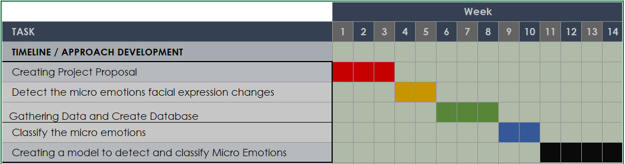**

**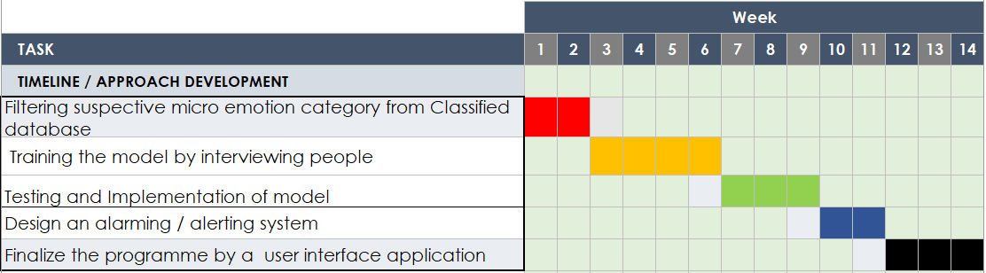**For semester -8,

# REFERENCES

In Harvard style